TC-DISP-020
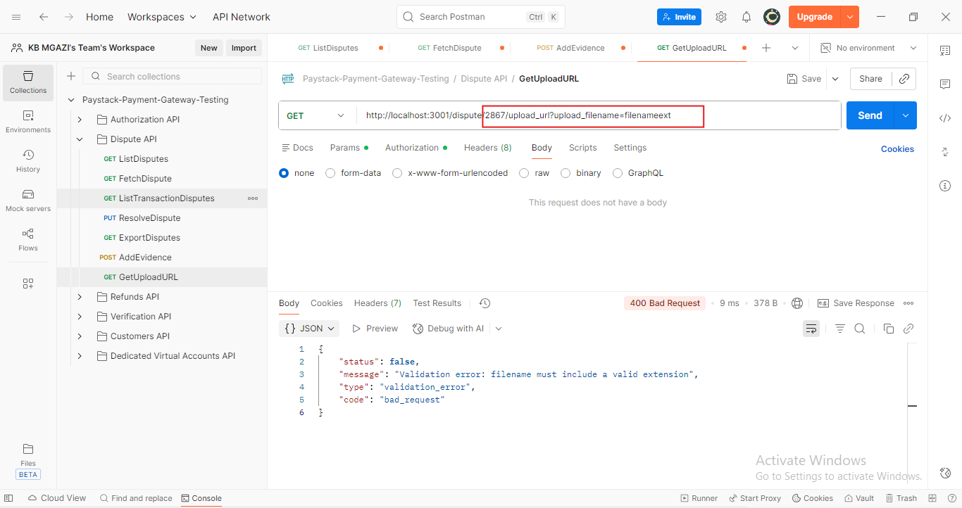
Response:
{
"status": false,
"message": "Validation error: filename must include a valid extension",
"type": "validation_error",
"code": "bad_request"
}

